

JAVA PROJECT REPORT ON
“Semester GPA and CGPA Calculation System”

Submitted by
DHANUSHYA.B
25BCS108

Under the Guidance of
Mr Aravind
Technical Trainer
Technical Department, KG College of Arts and Science

Academic Year: 2025 – 2026
APRIL 2026
Semester: I1

DECLARATION
I hereby declare that the project entitled “Semester GPA and CGPA Calculation System” submitted in partial fulfillment of the requirements for the course Java programming is a record of my original work carried out under the guidance of Mr.ARAVID, Technical Trainer, Technical Department, KG College of Arts and Science. I further declare that this project has not been submitted previously, either in part or in full, for the award of any degree, diploma, or other similar title, at this or any other institution. I have acknowledged all sources of information used in this project wherever applicable.

April 2026
Coimbatore

DHANUSHYA.B

CERTIFICATE
This is to certify that the project entitled “Semester GPA and CGPA Calculation System” is a bona fide work carried out by DHANUSHYA.B, I-B 2025 B.sc.Computer Science, KG College of Arts & Science, in partial fulfillment of the requirements for the course JAVA PROGRAMMING.
This project has been completed under my supervision and guidance during the academic period April 2026.

Place: SARAVANAMPATTI
Date:10-04-2026

Submitted for the Viva-Voce Examination held on 10.04.2026

Guide: Head of the Department
(Technical Trainer, KGCAS) (Technical Head, KGCAS)
MR.ARAVIND MR.BOOPALAN

TABLE OF CONTENTS
S. No. | Topics | Page. No.
1 | Introduction | 6
1.1 | Objective | 6
1.2 | Overview | 6
1.3 | Features | 7
2 | Program Analysis | 8
2.1 | Problem Definition | 8
2.2 | Project Overview | 8
2.3 | Scopes and Limitations | 8
3 | System Design | 10
3.1 | Modules | 11
4 | Methodology | 13
4.1 | Problem Analysis | 13
4.2 | System Design | 14
4.3 | Program Development | 16
4.4 | Testing and Validation | 17
4.5 | Result and Documentation | 18
4.6 | Algorithm | 19
4.7 | Flowchart | 20
5 | Source Code | 21
6 | Input and Output Screens | 25
7 | Discussion and Conclusion | 26
7.1 | Discussion | 26
7.2 | Conclusion | 26
8 | References | 27

ABSTRACT
The Semester GPA and CGPA Calculation System is a Java-based application designed to automate the calculation of students' academic performance. In many institutions, GPA and CGPA calculations are performed manually, which can lead to errors, delays, and inefficient record management. This project aims to simplify the calculation process by providing an automated system that computes GPA and CGPA accurately. The system allows users to enter subject grades and credit values, and automatically calculates the GPA for each semester and the overall CGPA. The application is developed using Core Java programming concepts, including classes, objects, methods, conditional statements, loops, and exception handling. The project can be implemented either as a console-based application or using Java Swing for a graphical user interface. The main objective of the system is to improve calculation efficiency, reduce human errors, and provide quick and accurate results. The system generates clear outputs showing subject-wise details, GPA, and overall CGPA. This project demonstrates the practical implementation of object-oriented programming concepts in Java and provides a basic foundation for developing more advanced student management systems in the future. The

- INTRODUCTION
In the education system, accurate calculation of academic performance plays a crucial role in evaluating students and ensuring transparency. Traditionally, many institutions rely on manual methods to calculate Grade Point Average (GPA) and Cumulative Grade Point Average (CGPA), where calculations are done using paper or basic calculators. This manual process is time-consuming and can often lead to calculation errors, delays, and difficulty in maintaining proper academic records. With the advancement of computer technology, automated calculation systems have become essential for improving efficiency and accuracy in academic management.
A computerized system helps students and institutions quickly calculate GPA and CGPA, generate results automatically, and maintain organized academic records. The Semester GPA and CGPA Calculation System is a Java-based application designed to automate the process of calculating students’ academic performance.
The system allows users to enter subject grades and credit values, and automatically calculates the GPA for each semester and the overall CGPA. The application generates clear and structured results displaying subject details, credits, GPA, and CGPA. This project is developed using Core Java programming concepts such as classes, objects, methods, conditional statements, loops, and exception handling.
The application can be implemented either as a console-based program or using Java Swing for a graphical user interface (GUI). The primary goal of this system is to reduce manual effort, improve calculation accuracy, and provide quick results. This project also demonstrates how Java programming can be applied to develop simple real-world academic applications.

1.1 Objective
The main objective of the Semester GPA and CGPA Calculation System is to develop a simple and efficient application using Core Java that automates the process of calculating students’ academic performance.
The specific objectives of this project are: To design and develop a Java-based GPA and CGPA calculation system To automate the calculation of GPA and CGPA using grades and credits To reduce manual errors in academic calculations To provide a user-friendly system for students to calculate results easily To demonstrate the implementation of Core Java programming concepts such as classes, objects, methods, loops, and conditional statements To generate clear and accurate output showing GPA and CGPA

1.2 Overview
The Semester GPA and CGPA Calculation System is a Java-based application developed to automate the calculation of students’ academic performance. The system takes input such as subject grades and credit values, processes the data using standard GPA and CGPA formulas, and generates accurate results. The application works in three main stages: input, processing, and output. In the input stage, the user enters subject-wise grades and corresponding credits.

During processing, the system calculates the Semester GPA and overall CGPA using predefined formulas. In the output stage, the system displays the calculated GPA and CGPA in a clear and structured format. This system is designed to be simple, efficient, and user-friendly. It can be implemented as a console-based application or enhanced with a graphical user interface using Java Swing. The system reduces manual effort, minimizes errors, and provides quick results, making it useful for both students and educational institutions.

1.3 Features
The Semester GPA and CGPA Calculation System provides a simple and efficient way to calculate students’ academic performance. It is designed to reduce manual work and ensure accuracy by automatically processing grades and credit values.

The system offers a user-friendly interface, quick result generation, and reliable performance. It supports multiple subjects and semesters, making it useful for tracking overall academic progress. Additionally, the system is flexible and can be enhanced into a complete student management application in the future. Key Features: 2.1 Problem Definition Automatic calculation of GPA and CGPA Easy input of grades and credit values Accurate and fast result generation Supports multiple subjects and semesters Reduces manual errors User-friendly interface (console/GUI) Clear and structured output display Lightweight and efficient system Based on Core Java and OOP concepts Scalable for future enhancements

2.PROGRAM ANALYSIS
Program analysis is an important phase in software development where the problem is studied in detail and the requirements of the system are identified. This stage helps in understanding how the system should work and what features are required to solve the problem efficiently.

In the GPA and CGPA Calculation System, the analysis phase focuses on identifying issues in the existing manual calculation process, such as errors, time consumption, and difficulty in handling multiple subjects and semesters. Based on this analysis, a computerized solution is proposed to automate the calculation process, improve accuracy, and provide quick and reliable results.
2.1 Problem Definition
In many educational institutions, the calculation of GPA and CGPA is performed manually using traditional methods such as paper-based calculations or basic calculators. This approach is time-consuming, prone to human errors, and inefficient when dealing with multiple subjects and semesters.
It also makes it difficult to maintain accurate academic records and delays the process of result generation. Due to these limitations, students and staff may face difficulties in obtaining quick and reliable academic performance results. Therefore, there is a need for an automated system that can efficiently calculate GPA and CGPA, reduce errors, , and provide accurate and well-organized results.
2.2 Project Overview
The calculation of and is an essential part of evaluating students’ academic performance. In many institutions, this process is carried out manually, which can lead to inaccuracies and inefficiencies. As the number of subjects and semesters increases, the complexity of calculations also grows, making manual methods difficult to manage. Manual systems often result in errors, consume more time, and lack proper organization of academic records. These issues can affect the accuracy of results and delay performance evaluation. Therefore, there is a need for an automated system that simplifies the calculation process, ensures accuracy, and provides quick and reliable results for students and institutions. This project is implemented using Core Java programming concepts and can be developed as either a consolebased application or a Java Swing GUI application. It utilizes object-oriented programming principles such as classes, objects, methods, loops, and conditional statements to efficiently calculate GPA and CGPA. save time 2.2 Project Overview GPA CGPA

Benefits:
• Reduces manual work
• Improves accuracy
• Provides fast data access
• Easy to use interface
2.3 Scopes and Limitations
The system focuses on automating and simplifying the process of evaluating students’ academic performance. It provides a reliable and efficient way to calculate GPA for individual semesters and CGPA across multiple semesters using subject grades and credit values. The system ensures accuracy, reduces manual effort, and delivers quick results, making it useful for both students and academic institutions.

The scope of this project includes handling multiple subjects with different credit weights, supporting calculations for several semesters, and displaying clear and structured results. It can be developed as a consolebased application or extended into a graphical user interface using Java Swing. The system is designed to be simple, user-friendly, and efficient, making it suitable for basic academic use. In addition, the project has the potential for future enhancements such as integrating a database for storing student records, generating detailed reports and transcripts, analyzing academic performance, and developing web or mobile-based applications.

It can also be expanded into a complete student management system with features like attendance tracking, course management, and result analysis.

Scope Highlight
Automates GPA and CGPA calculation Supports multiple subjects and semesters
Ensures accuracy and reduces errors
Provides quick and clear results Can be implemented using Core Java (Console/GUI)
Scalable for future enhancements like database and web integration

3.SYSTEM DESIGN

System design is the stage where the structure and components of the system are planned before the actual implementation. In this phase, the system is divided into different modules, and the workflow of the application is defined.

Proper system design helps in organizing the program efficiently and makes development easier. The Semester GPA and CGPA Calculation System is designed as a simple application where users can enter subject grades and credit values to calculate GPA and CGPA automatically. The system is divided into several modules to perform specific tasks.

Each module is responsible for handling a particular function of the system, such as input handling, calculation, and result display.

3.1 Modules
The system consists of the following modules:

1. Input Module
- Accepts number of subjects, marks/grades, and credits.

2. Grade Conversion Module
- Converts marks into grade points based on predefined scale.

3. GPA Calculation Module
- Calculates semester GPA using credits and grade points.

4. CGPA Calculation Module
- Computes overall CGPA from all semesters.

5. Performance Module
- Classifies result (Excellent, Very Good, Good, Average).

6. Output Module
- Displays GPA, CGPA, and performance clearly.

7. Error Handling Module
- Handles invalid or incorrect inputs.

4.METHODOLOGY

The methodology describes the step-by-step process followed to design and develop the GPA & CGPA Calculator.

1. Requirement Analysis
- Identify the need for calculating GPA and CGPA.
- Understand inputs required: subjects, marks/grades, and credits.

2. System Design
- Divide the system into modules:
  - Input
  - Grade Conversion
  - GPA Calculation
  - CGPA Calculation
  - Output
- Plan the workflow of the program.

3. Data Collection
- Collect input data from the user:
  - Number of subjects
  - Marks or grades
  - Credits for each subject

4. Processing
- Convert marks into grade points.
- Apply formulas to calculate:
  - GPA for each semester
  - CGPA for overall performance

5. Implementation
- Develop the program using Java.
- Use functions/methods for each module.
- Apply logic for calculations and conditions.

6. Testing
- Test with different inputs:
  - Valid inputs
  - Invalid inputs
- Ensure correct GPA and CGPA results.

7. Result & Output
- Display calculated GPA and CGPA.
- Show performance level (Excellent, Good, etc.).

4.1. Problem Analysis
Manual calculation of GPA and CGPA is time-consuming and prone to errors. Students often find it difficult to convert marks into grade points and calculate overall performance accurately.
There is no simple method to handle multiple subjects, credits, and semesters, which increases complexity and confusion.
To overcome these issues, a system is required to automate the calculation process, reduce errors, and provide quick and accurate results along with performance evaluation.

4.2. System Design
The system is designed in a modular way to ensure simplicity, accuracy, and easy understanding. Each module performs a specific function in the GPA & CGPA calculation process.

Modules in System Design
- Input Module
- Grade Conversion Module
- GPA Calculation Module
- CGPA Calculation Module
- Performance Module
- Output Module

System Workflow
- User enters subject details (marks/grades and credits)
- Marks are converted into grade points
- GPA is calculated for the semester
- CGPA is calculated for overall semesters
- Performance is analyzed
- Results are displayed to the user

Design Approach
- Uses modular design for better organization
- Each module is implemented using separate methods
- Ensures easy maintenance and scalability

.4.3. Program Development
The GPA & CGPA Calculator is developed using Java programming language. The program is designed to calculate semester GPA and overall CGPA based on user inputs such as marks/grades and subject credits.

Development Details
- Language Used: Java
- Platform: Console-based application
- Approach: Modular programming using methods

Working of the Program
- The program asks the user to enter:
  - Number of subjects
  - Marks or grades
  - Credits for each subject
- Marks are converted into grade points using predefined conditions.
- The program calculates:
  - GPA for a semester
  - CGPA for multiple semesters
- The result is displayed along with performance analysis.

Features of the Program
- Simple and user-friendly interface
- Accurate and fast calculation
- Handles multiple subjects and semesters
- Displays performance level

4.4. Testing and Validation
Testing and validation are performed to ensure that the GPA & CGPA Calculator works correctly, accurately, and without errors.

Testing
The program is tested using different types of inputs:
- Valid Inputs
  - Correct marks/grades and credits
  - Proper number of subjects
  - Ensures accurate GPA and CGPA calculation
- Invalid Inputs
  - Negative marks or credits
  - Marks beyond valid range
  - Incorrect data types (letters instead of numbers)
- Boundary Testing
  - Minimum and maximum marks (e.g., 0 and 100)
  - Edge grade values

Validation
- Ensures input values are within acceptable limits
- Verifies correct grade conversion
- Confirms accurate calculation of GPA and CGPA
- Displays error messages for invalid inputs

Result of Testing
- The system produces accurate and consistent results
- Errors are handled properly
- The program works efficiently for different input cases

4.5. Result and Documentation
The GPA & CGPA Calculator was successfully developed and tested.
The system accurately calculates:
- Semester GPA
- Overall CGPA
It provides quick results along with performance analysis, making it easy for users to understand their academic progress.
The program works efficiently for different inputs and handles errors properly.

4.6. Algorithm
Start the program
- Input number of subjects
- Initialize variables
  - totalCredits = 0
  - totalGradePoints = 0
- For each subject, repeat:
  - Input marks/grade
  - Input credit
  - Convert marks into grade point
  - Calculate: gradePoint × credit
  - Add to totalGradePoints
  - Add credit to totalCredits
- Calculate GPA
  - GPA = totalGradePoints / totalCredits
- Input number of semesters

- For each semester, repeat:
  - Input GPA
  - Add to totalGPA
- Calculate CGPA
  - CGPA = totalGPA / number of semesters

- Display results
  - Show GPA
  - Show CGPA
  - Show performance level
- End the program

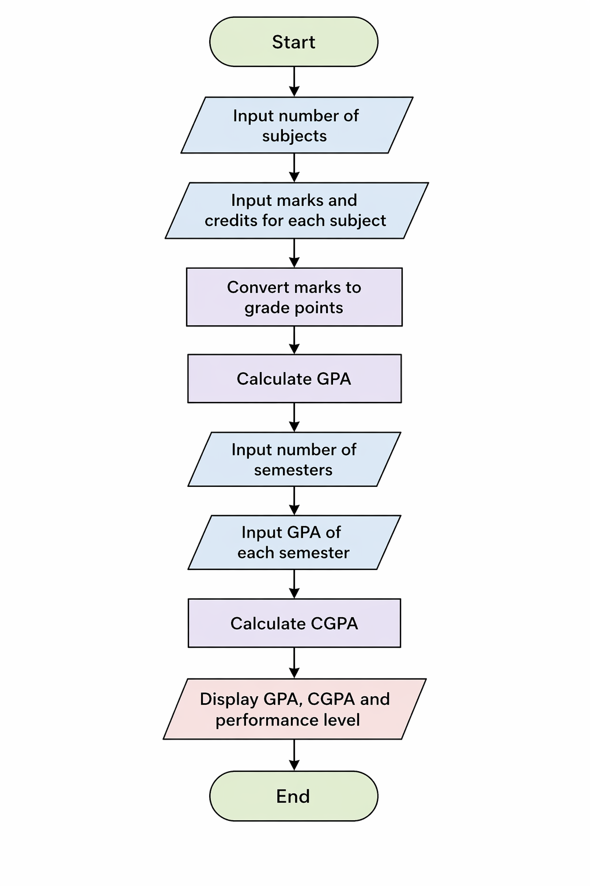
4.7. Flowchart

5.SOURCE CODE
import java.util.Scanner;
This module provides a menu-driven interface for the user. It displays options such as entering subject
details, calculating GPA, calculating CGPA, and exiting the program. It helps the user navigate through the
system easily.
class GPACalculator4 {

public static String getPerformance(double gpa) {
if (gpa >= 9) {
return "Excellent";
} else if (gpa >= 8) {
return "Very Good";
} else if (gpa >= 7) {
return "Good";
} else if (gpa >= 6) {
return "Average";
} else {
return "Need Improvement";
}
}

public static double[] calculateGPA(int subjects, Scanner sc) {
double totalCredits = 0;
double totalGradePoints = 0;

for (int i = 1; i <= subjects; i++) {
System.out.println("\nSubject " + i);

System.out.print("Enter Credits: ");
double credit = sc.nextDouble();

System.out.print("Enter Grade Point: ");
double grade = sc.nextDouble();

totalCredits += credit;
totalGradePoints += (credit * grade);
}

// Avoid division by zero
if (totalCredits == 0) {
System.out.println("Invalid input (credits cannot be 0)");
return new double[]{0, 0};
}

double gpa = totalGradePoints / totalCredits;

System.out.println("---------------------------------");
System.out.println("Semester GPA = " + String.format("%.2f", gpa));
System.out.println("Performance: " + getPerformance(gpa));
System.out.println("---------------------------------");

return new double[]{totalCredits, totalGradePoints};
}

public static void main(String[] args) {

Scanner sc = new Scanner(System.in);

System.out.println("=================================");
System.out.println(" GPA & CGPA CALCULATOR");
System.out.println("=================================");

System.out.print("Enter Number of Semesters: ");
int semesters = sc.nextInt();

double overallCredits = 0;
double overallGradePoints = 0;

for (int i = 1; i <= semesters; i++) {
System.out.println("\n******** SEMESTER " + i + " ********");

System.out.print("Enter Number of Subjects: ");
int subjects = sc.nextInt();

double[] result = calculateGPA(subjects, sc);

overallCredits += result[0];
overallGradePoints += result[1];
}

// Avoid division by zero
if (overallCredits == 0) {
System.out.println("Cannot calculate CGPA");
} else {
double cgpa = overallGradePoints / overallCredits;

System.out.println("\n=================================");
System.out.println(" FINAL RESULT");
System.out.println("=================================");
System.out.println("Final CGPA = " + String.format("%.2f", cgpa));
System.out.println("Overall Performance: " + getPerformance(cgpa));
System.out.println("=================================");
}

sc.close();
}
}
}

6.INPUT AND OUTPUT SCREENS

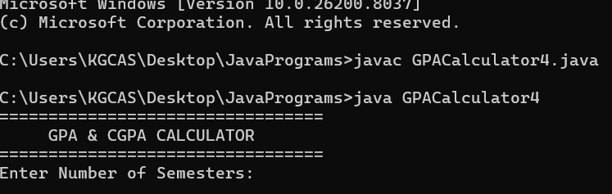
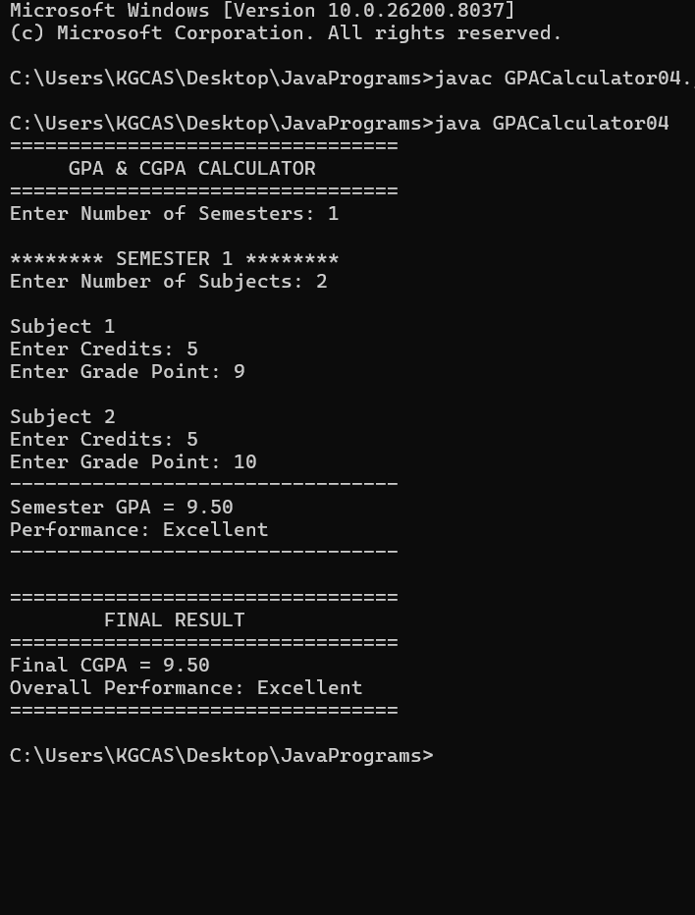

7.DISCUSSION & CONCLUSION

7.1 Discussion
The project was developed to simplify and automate the calculation process, reducing manual effort and errors. During development, various concepts of programming such as input handling, conditional statements, loops, and functions were applied effectively.
The system was tested with multiple inputs to ensure accuracy and reliability. It successfully calculates results based on user-provided data and displays them in an understandable format. The design of the system is simple and user-friendly, making it easy for users with basic knowledge to operate.
Some challenges faced during the project included handling incorrect inputs and ensuring proper validation. These were resolved by implementing appropriate conditions and checks.
Overall, the project demonstrates the practical application of programming skills in solving real-world problems.

7.2 Conclusion
The project successfully achieved its objective of developing an efficient and accurate system. It helped in improving understanding of programming concepts, system design, and problem-solving techniques.
The developed system is reliable, easy to use, and reduces the complexity involved in manual calculations. It can be further enhanced by adding advanced features such as a graphical user interface (GUI) and database integration.
This project serves as a strong foundation for developing more complex and real-time applications in the future.

8.REFERENCES
The following resources were used during the development of this project:

Books
• Herbert Schildt – Java: The Complete Reference
• E. Balagurusamy – Programming with Java

Websites
• https://www.oracle.com/java
• https://www.geeksforgeeks.org
• https://www.w3schools.com
• https://www.javatpoint.com

